**IMPLEMENTATION OF RFID APPLICATION USING DUALBAND MONOPOLE ANTENNA**

*Mini Project-1 report submitted in partial fulfilment of the requirements for the award of degree of*

**Bachelor of Technology**

**in**

**Electronics and Communication Engineering**

**by**

**SHAIK NOWSHEEN (19131A04M0)**

**Under the guidance of**

**MR. SANTOSH KUMAR NIMMALA**

**Assistant Professor**



COLLEGE OF ENGINEERING

(AUTONOMOUS)

**Department of Electronics and Communication Engineering**

**GAYATRI VIDYA PARISHAD COLLEGE OF ENGINEERING** (AUTONOMOUS)

**(Affiliated to J.N.T University, Kakinada, A.P) VISAKHAPATNAM- 530 048**

**NOVEMBER,2021**



# CERTIFICATE

This is to certify that the mini project work titled **Implementation Of RFID Application Using Dual Band Monopole Antenna** a bona fide record of the work done by **Shaik Nowsheen (19131A04M0)** to the Department of Electronics and Communication Engineering, **Gayatri Vidya Parishad College of Engineering (Autonomous)**, **Visakhapatnam**, affiliated to **Jawaharlal Nehru Technological University**, **Kakinada** in partial fulfilment of the requirement the award of the degree of **Bachelor of Technology** in electronics and communication engineering during the academic year 2021-22.

**Under the guidance of: Head of the Department:**

Dr. N. DEEPIKA RANI

Professor and head,

Dept. of ECE,

GVPVOE(A)

MR. SANTHOSH KUMAR NIMMALA,

Assistant Professor,

Dept. Of ECE,

GVPCOE(A)

# ACKNOWLEDGEMENTS

# 

We express our deep sense of gratitude to our esteemed institute **“Gayatri Vidya Parishad College of Engineering (Autonomous)”** which has provided us an opportunity to fulfill the most cherished desire to reach our goal.

We are highly indebted to **MR. SANTOSH KUMAR NIMMALA** Assistant Professor, Department of Electronics and Communication, who has been our project guide, Chief instructor and our mentor. We thank her for her guidance and constant supervision also for her support in completing the project.

With the great sense pf pleasure and privilege, I extend my gratitude and sincere thanks to, **DR. A. BALA KOTESWARA RAO,** Principle, Gayatri Vidya parishad College of Engineering (Autonomous) for his continuous encouragement during the course of study.

We would also like to express our deep hearted thanks to **Dr. N. DEEPIKA RANI**, Professor and Head of the Department (Electronics and Communication Engineering) for his valuable advice and guidance.

Our deep hearted thanks to the faculty members of our department for their value-based imparting of theory and practical subjects, which we have to put into use in our project.

We are indebted to the non-teaching staff for their cooperation. We would like to thank our parents and friends for all their help and support in making our project a success.

By

**Shaik Nowsheen(19131A04MO)**

ABSTRACT

Over the past decade, radio-frequency identification (RFID) technology has attracted noteworthy attention and become very popular in different applications such as identification, management and monitoring. Antenna is one of the key factors in RFID systems. In this report, a dual-band microstrip-fed monopole antenna has been introduced for RFID application. The structure of antenna is like a modified F-shaped radiator. Dual band antennas have lots of practical uses and operate on two frequencies, these can work either of these frequencies one at a time or simultaneously depending on the capability of individual antenna. It is especially used for mobile devices and the biggest advantage of dual mode antenna is their ability to provide a strong, stable, wireless connections in often difficult to reach locations. The structure of the antenna is planar, simple to design and fabricate, easy to integrate with RF circuit and suitable for use in RFID systems. Simulations have been carried out using High Frequency Structure Simulator software (HFSS)

# INDEX

**CERTIFICATE………………………………………………………………….........2**

**ACKNOWLEDGEMENTS…………………………………………………………..3** **ABSTRACT…………………………………………………………………………...4**

**CONTENTS…………………………………………………………………………...5**

**CHAPTER 1**  **INTRODUCTION…………...……………………………………......7**

1.1 OBJECTIVE OF THE PROJECT………………………………...9

## **CHAPTER 2 : ANTENNAS**……………...……….........................10

2.1 INTRODUCTION……………………………………………………....11

2.2ADVANTAGES OF ANTENNA ………………………………12

## CHAPTER 3 **:RFID TECHNOLOGY**

## CHAPTER 4: MONOPOLE ANTENNAS……………….…………………………14

3.1 INTRODUCTION…………………………………………...…………15

3.2VARIOUS SHAPES OF PLANAR MONOPOLE ANTENNA…………..……………....

FR4 SUBSTARTE--------------------------------------------------------------------19

5.1INTRODUCTION ----------------------------------------------------------------20

5.2 CHARACTERISTICS OF FR4 SUBSTRATE-------------------------------20

5.3.1 LOSS TANGENT----------------------------------------------------------20

5.3.2 RELATIVE PERMITTIVITY--------------------------------------------20

## ……….………………….17

## CHAPTER 5……………………………………………........................27

**CHAPTER 6** **RESULTS…………………...……………………………………….31**

A--------30

**CONCLUSION………………………………………………………………………34 REFERENCES…………………………………………………………………........35**

# LIST OF FIGURES

## Fig Name of the Figure Page no

2.1 Antenna System 11

3.1 Monopole antenna 15

4.1 Different shapes of planar monopole antenna 19

4.2 20

4.3 System identification 23

4.4 Inverse modelling 24

4.5 Linear predictor 24

4.6 Adaptive notch filter 25

4.7 Active Noise Canceller 26

6.1 LMS (Input vs Output) 32

6.2 MSE Comparison (118 & 119 Record Signals) 33

6.3 RMSE Comparison (118 & 119 Record Signals) 33

# LIST OF TABLES

**Table Name of the Table Page no**

6.1 Tabulation of MSE, RMSE & SNR Values 32

# 

CHAPTER - 1

# INTRODUCTION

RFID is a recent outstanding technology which uses radio frequency (RF) signals for the identification of objects and has been employed in many applications, such as service industries and moving vehicle identification [1]. In general, RFID is a paste and tag antenna for the purpose of identification and tracking by radio. An RFID system contains three major components: a transponder, a reader, and a computer for data processing. The reader (Interrogator) includes an antenna, which communicates with the TAG [2]. The antenna should be inexpensive, light, simple, and easy to fabricate [3].

Printed monopole antennas are very attractive and suitable for dual-band or multi-band applications owing to their simple structures, compact size, good impedance matching, and omnidirectional radiation patterns. Multi-band monopole antennas can be realized by employing parasitic structures, slots, or slits in the antenna configuration or using various radiating elements with different shapes [14]. Configuration of the presented design consists of a modified F-shaped radiation patch, a rectangular microstrip feed-line, and a ground plane. The antenna with a planar structure is designed on an FR-4 substrate.

# 1.1 OBJECTIVE OF PROJECT:

The main objective of the project is to design a dual band monopole antenna for RFID applications using HFSS. The antenna can be operated at two operating frequencies which is accomplished by using planar monopole antenna instead of conventional monopole antenna. The return loss is better by using the designed antenna. The designed antenna is planar, simple to design and fabricate, easy to integrate with RF circuit, and suitable for use in RFID applications. The project aim is to design an antenna which provide omnidirectional radiation patterns and appropriate gain values at both of operation bands.

CHAPTER - 2

ANTENNAS

## **2.1. INTRODUCTION**

An antenna is an array of conductors (elements), electrically connected to the receiver or transmitter. Antennas can be designed to transmit and receive radio waves in all horizontal directions equally (omnidirectional), or preferentially in a particular direction (directional, or high-gain, or “beam” antennas). An antenna may include components not connected to the transmitter, parabolic reflectors, horns, or parasitic elements, which serve to direct the radio waves into a beam or other desired radiation pattern.

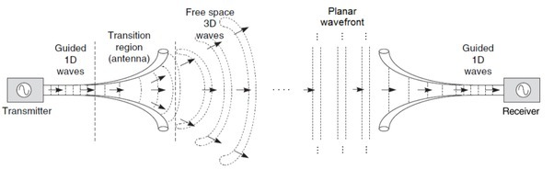

Figure .1 Antenna system

Antennas are required by any radio receiver or transmitter to couple its electrical connection to the electromagnetic field. Radio waves are electromagnetic wave which carry signals through the air (or through space) at the speed of light with almost no transmission loss.

### **MONOPOLE ANTENNA**

A monopole antenna is one half of a dipole antenna, almost always mounted above some sort of ground plane. Multi-band monopole antennas can be realized by employing parasitic structures, slots, or slits in the antenna configuration or using various radiating elements with different shapes [14]. Configuration of the presented design consists of a modified F-shaped radiation patch, a rectangular microstrip feed-line, and a ground plane. The antenna with a planar structure is designed on an FR-4 substrate

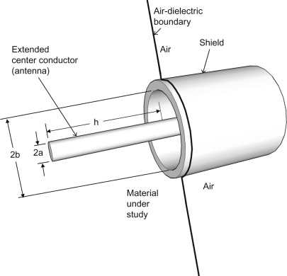

Figure .2 Monopole antenna

**PLANAR MONOPOLE ANTENNA**

3.1 INTRODUCTION:

The wire element of a normal monopole is replaced to create a planar monopole. Monopoles produce a lot of bandwidth. In todays and future wideband wireless applications, the planar monopole is a key component. The radiation performance of these antennas has also been demonstrated to be acceptable over a wide frequency range. Planar monopole antennas can also provide band-notching and multi-band advantages. The monopole antenna is one of the most widely used antennas in mobile communication systems. Planar monopole antennas can be tuned to have a very wide impedance bandwidth while yet providing adequate radiation performance.

3.2 Various Shapes of Planar Monopole Antenna:

The replacing of wire element planar element, with various shapes, increases the surface area of the monopoles, which directly impact on bandwidth.

The proposed planar monopoles use radiators of different shapes, including triangle, rectangle square, circle, annual ring, vertical ellipse, horizontal ellipse, pentagon and hexagon.

Specifically, the circular, elliptical, square, rectangular, hexagonal and pentagonal have more significance in providing enlarged impedance bandwidth.

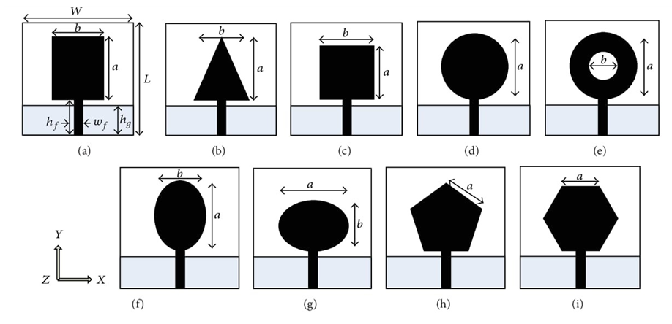

ADVANTAGES OF PLANAR MONOPOLE ANTENNA:

● Low cost.

● Ease of fabrication.

● Wide operation bandwidth.

● Omnidirectional radiation.

**Dual band antenna:**

A dual-band antenna is an antenna that can send and receive radio frequency signals at two distinct frequencies. Depending on their configuration, these antennas are capable of using either of the two frequencies individually or at the same time.

The principle of the dual frequency operation is to make the antenna a combination of two monopoles connected in parallel at the feed point,each operating at a specified frequency mode.

**GROUND PLANE:**

A ground plane, in antenna theory, is a huge conducting surface, such as the Earth, that is connected to the transmitter's ground wire and serves as a reflecting surface for radio waves. A ground plane on a printed circuit board is a broad expanse of copper foil connected to the power supply ground terminal and used as a return path for current from various components on the board.

A ground plane is a horizontal conducting surface that serves as part of an antenna to reflect radio waves from the other antenna elements in telecommunication. It is not necessary for the plane to be tethered to the ground. The form and size of the ground plane are important factors in defining its radiation characteristics, including gain.

CHAPTER - 3

RFID stands for radio frequency identification. RFID tags are small chips (usually comes in a smart card or visiting card shape) that are used in our day to day life for unlocking hotel rooms, entering into cars etc. These tiny chips along with an RFID reader form the RFID system.

RFID technology was first used during worldwar2 to identify enemy aircrafts. Since then RFID technology has evolved and is now used in many different industries. One clean example is a smart warehouse where the process of warehousing is automated using RFID Technology.

An RFID system consists of two parts **1) RFID Reader** and **2) RFID Tag**.

Data is stored in the RFID tag electronically. This data is retrieved by the reader using electromagnetic waves. Tags can store only a few kilo bytes of data.

The operation of an RFID reader is very much similar to barcode scanning method which uses UPC (Universal Product Codes) codes. In some applications, RFID has advantages over the barcode system.

Take a look at the image given below. This is how the inside of an RFID tag look like (a smart card shape RFID tag). RFID tags come in different shape and size (say like that of a key chain or a button cell etc).



The copper wire acts as an antenna and also provides the necessary power to the tag. This antenna is connected to a chip as shown in the image given below.



This chip is the key component of an RFID tag. The chip has an EEPROM (which stores the unique identification code and other essential data if any) and also has a circuitry for the logical functioning of the chip.

RFID Tags have an integrated chip embedded inside it which will energise itself in an electromagnetic field. The chip inside this RFID tag stores a unique information which we call as the RFID key- which is usually a 12digit code including numbers and alphabets. This code is unique to each and every RFID tag. This code inside the chip can be read by an RFID Reader. A

typical RFID tag will be in the shape of a smart card (as shown above). However, there are RFID tags in other shapes as well. An RFID tag comes with a chip with memory to store RFID identification code, a coil and a modulator. The coil is to energise the chip when the tag is placed near an RFID reader (which also has a coil inside) via electromagnetic induction. The modulator modulates the RFID code/key according to the frequency and transmits the information electromagnetically so that the RFID Reader can receive the information. The coil also serves as an antenna to send the modulated information to air medium.

## **Advantages**

1.   **Security –**The data on [RFID systems](https://www.se.com/in/en/product-category/4900-sensors-and-rfid-system/) are usually secure because it takes specialised equipment to read the data. This helps to maintain the lock system security.

2.   **Convenience –**It only takes up a fraction of a second to put an RFID key in the proximity to unlock the security system. The procedure is highly convenient and fast.

3.   **Size –**The size of the card is handy and the same as a regular bank card. Thus it is easy to store. Users have fewer chances of forgetting these cards when going to the place where they require access.  RFID cards are convenient and easy to store.

4.   **Diverse –**RFID locks come with different ranges of cams and spindle length that can fit a wide range of doors and furniture, making them suitable for any business or applications.

5.   **Master Card Functionality –**Different kinds of locks can use one RFID key card to program. This saves the users from the mess of having different cards for different locks while allowing each lock to have independent access policies.

## **Disadvantages**

Despite offering numerous advantages, the [**RFID system**](https://www.se.com/in/en/product-category/4900-sensors-and-rfid-system/)even has some of the disadvantages, which are listed below:

**1.    Lost Keycard –**Unlike the traditional locks, forgetting or misplacing the modern keycard gives you a double headache of figuring out how to open the lock or track back the keycard to access the appliances.

**2.    Hacker Alert –**The **RFID system** can be hacked by someone who is tech-savvy, thus offering a security issue.

**3.    Power Shortage Issue –**Electric RFID keycards malfunction when power outages, causing some lockers to shut you out or leave the lockers open. It offers a lot of uncertainty to the users of keycards.

**4.    Expensive to Set Up –**The Set-Up of RFID is expensive and complex. The set-up requires that  locks are wired with a secured system that can be accessed, controlled and logged through the computer system.

**5.    Not Totally Hassle-Free –**Users  need to manually change their computer clock twice a year. This is required if the server computer is not connected to the internet or if there is a time-based access restriction.

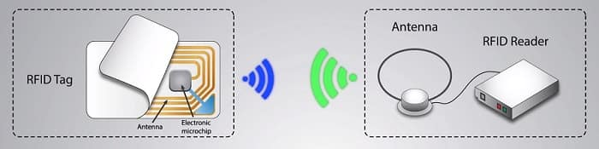

Figure RFID system components

**FR-4 SUBSTRATE**

**INTRODUCTION:**

Substrate is a dielectric material which acts as a capacitor in order to produce electric field between two metal surfaces which are ground plane and planar monopole antenna in our proposed antenna. Substrate materials plays an important role in antenna design, production and finished performance. substrate choice largely effects radiation efficiency/patterns, antenna dimensions, and instantaneous bandwidth.

FR-4 glass epoxy is a popular and versatile high-pressure thermoset plastic laminate grade with good strength to weight ratios. With near zero water absorption, FR-4 is most commonly used as an electrical insulator possessing considerable mechanical strength. The material is known to retain its high mechanical values and electrical insulating qualities in both dry and humid conditions. These attributes, along with good fabrication characteristics, lend utility to this grade for a wide variety of electrical and mechanical applications.



Figure FR-4 substrtate

**CHARACTERISTICS OF FR4 SUBSTRATE:**

**LOSS TANGENT:**

The tan(𝛿), which is a measure of the rate at which energy carried by an electromagnetic field (RF) going through a dielectric is absorbed by that dielectric, is used to define the dielectric loss tangent.

The loss tangent of proposed substrate is 0.025

**RELATIVE PERMITTIVITY**

Relative permittivity is the ratio of the capacitance of a capacitor using that material as a dielectric, compared with a similar capacitor that has vacuum as its dielectric. Relative permittivity is also commonly known as the dielectric constant.

The relative permittivity of proposed substrate is 4.4.

CHAPTER - 4

# DESIGN USING HFSS

**INTRODUCTION:**

HFSS is a full-wave electromagnetic field simulator with a familiar Microsoft Windows graphical user interface for 3D volumetric passive device simulation. It has a simulation feature as well as a familiar Microsoft Windows graphical user interface. It combines simulation, visualization, solid modelling, and automation in an easy-to-use environment to provide quick and accurate answers to 3D EM challenges.

The design comprises of a modified F-shaped radiation patch, a rectangular microstrip feed-line and a ground plane. The antenna with planar structure is designed on FR-4 substrate. . A 1.6 mm thick FR4 substrate of relative permittivity 4.4 and loss tangent of 0.025 is used as the system circuit board. The overall size of FR-4 dielectric is 38 × 45 × 1.6 mm3

**DESIGN OF PLANAR MONOPOLE ANTENNA ON SUBSTRATE USING HFSS:**

The design comprises of meandered planar monopole antennas on the non-ground portion. The antennas are placed at the opposite ends of FR4 substrate. The antenna is impedance matched with the microstrip line of 50ohms.The substrate is sandwiched between planar monopole antennas and defected ground structure.

|  |  |  |  |  |  |
| --- | --- | --- | --- | --- | --- |
| Parameter | Value(mm) | Parameter | Value(mm) | Parameter | Value(mm) |
| W sub | 28 | L sub | 40 | H sub | 1.6 |
| W f | 3 | L f | 20 | W | 10 |
| W1 | 4 | W2 | 4 | L | 8 |
| L1 | 6 | L2 | 3 | L3 | 3 |
| L4 | 3 | L gnd | 17 | W3 | 3 |

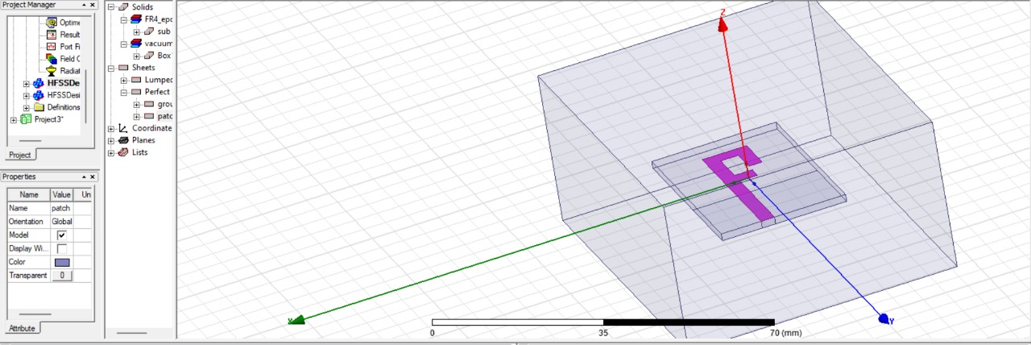

Figure Design of dual band monopole antenna

**RESULTS**

**7.1 CHARACTERISTICS OF PROPOSED ANTENNA SYSTEM:**

**7.1.1 RETURN LOSS :**

Return loss is the measure in relative terms of the power of the signal reflected by a discontinuity in a transmission line.

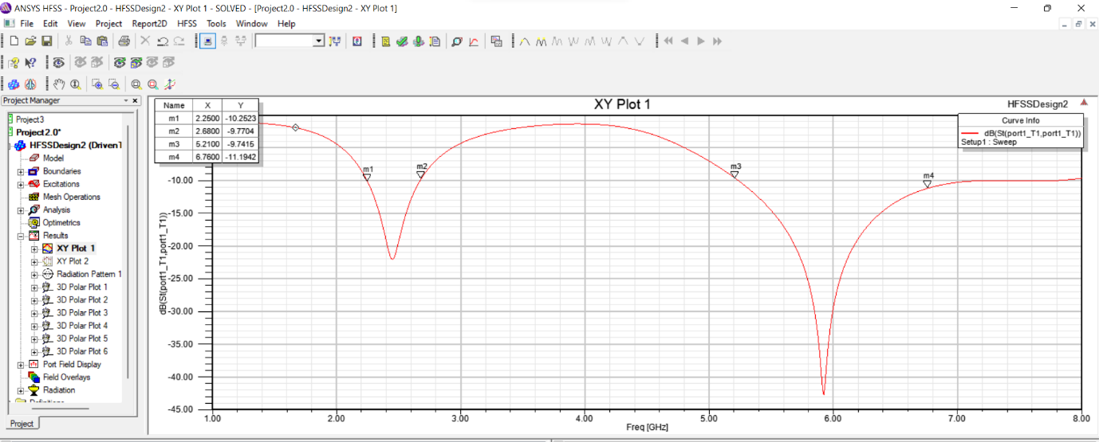

Figure 6 Return loss characteristics of dual band monopole antenna

**7.1.3 3D PLOTS AT OPERATING FREQUENCY 5.8GHz:**

**7.1.3.1RADIATION PATTERN OF DUAL-BAND MONOPOLE ANTENNA AT OPERATING FREQUENCY 5.8GHZ:**

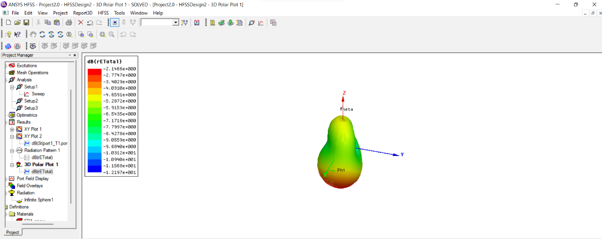

Figure Radiation pattern 3D plot at 5.8 GHz

**7.1.3.2.GAIN OF DUAL-BAND MONOPOLE ANTENNA AT OPERATING FREQUENCY 5.8GHZ:**

Antenna gain is the ability of the antenna to radiate more or less in any direction compared to a theoretical antenna. The gain of proposed dual-band monopole antenna is

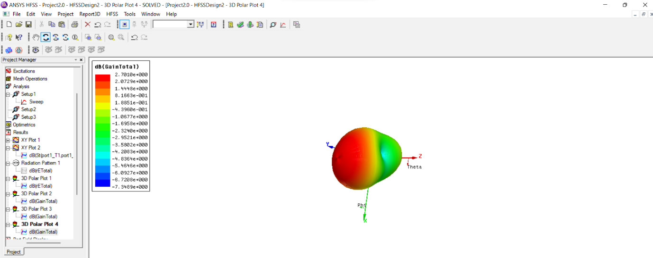

Figure Gain 3D plot at 5.8GHz

**7.1.3.3. DIRECTIVITY OF DUAL-BAND MONOPOLE ANTENNA AT OPERATING FREQUENCY 5.8GHZ:**

Directivity is an antenna which measures the degree to which the radiation emitted is concentrated in a single direction. The directivity of proposed antenna is . The red area in the plot indicates the maximum directivity of the antenna

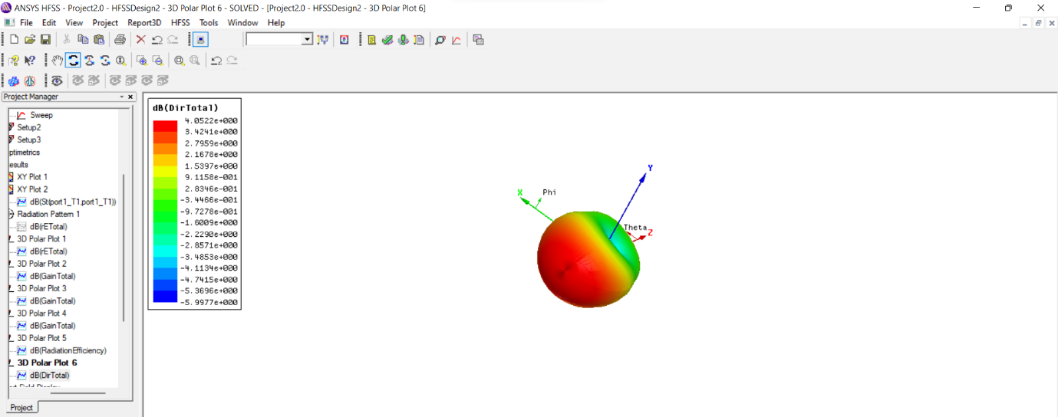

Figure Directivity 3D plot at 5.8GHz

The motive behind the presented design to achieve a dual-band characteristic for use in RFID applications. This has been achieved by using the presented antenna design with a modified radiation patch. Return loss characteristics of rectangular monopole antenna ,the antenna witha T-shaped radiating patch, and the antenna with a modified F-shaped radiator are shown.

# 

# 

**CONCLUSION**

Simulation of dual-band monopole antenna using HFSS reveals that the antenna is acceptable for the handset applications with two operating frequencies because of its compact size. A design of dual-band antenna covering 5.8 GHz has been presented for RFID applications. To achieve the dual-band function, a monopole antenna with a radiation patch similar to F shape was designed and its properties were investigated .The antenna provides omnidirectional radiation patterns with appropriate gain values at both of the operation bands. The antenna is simple and might be a suitable candidate for use in RFID systems. . The antenna is simple and might be a suitable candidate for use in RFID systems.

**REFERENCES**

1. Finkenzeller, K. RFID *Handbook:* *Radio-Frequency Identification Fundamentals and Applications*, 2nd ed.; Wiley: New York, NY, USA, 2004.
2. Chawla, V.; Ha, D.S. An overview of passive RFID. *IEEE Commun*. Mag. 2007, 45, 11–17. [CrossRef]
3. Bell, M.S*. RFID Technology and Applications*; Cambridge University Press: London, UK, 2011; pp. 6–8.
4. Siakavara, K.; Goudos, S.; Theopoulos, A.; Sahalos, J. Passive UHF RFID tags with specific printed antennas for dielectric and metallic objects applications. *Radioengineering* 2017, 26, 735–745.
5. Zeng, Y.; Chen, Z.N.; Qing, X.; Jin, J.-M. A directional, closely spaced zero-phase-shift-line loop array for UHF near-field RFID reader antennas. IEEE Trans*. Antennas Propag.* 2018, 66, 5639–5642.
6. Constantine A.Balanis , *Antenna Theory-Analysis* ,4th Edition, Wiley Publication,2005

**SIGNATURE OF THE GUIDE SIGNATURE OF THE STUDENT**